FIRST BAPTIST CHURCH OF TAYLORSVILLE CHRISTIAN SCHOOL
125 Hwy 37 N Taylorsville, MS 39168 (601)785-4747 christianschool@fbctaylorsville.org

2024-2025 Tuition Rates
Registration/Book Fee AFTER MAY 31, 2024: $300.00 PER STUDENT
Per Student
$200

Tuition & Payment Options | Tuition Total Prepay by Semester  due August 1 &  (Paying in full December 1 | **ACH Monthly Draft  (Drafted on the first business day of each month,  August-May)

K5 Part-time 8 am-11:30 am M-F  K5-9TH grade (8 am-2:45 pm M-F)  K5-9TH grade (8 am-2:45 pm M-F) (2 children enrolled)  K5-9TH grade (8 am-2:45 pm M-F)  (3 children enrolled) | $2,250 | $1,125 | $225
 | $3,750 | $1,875 | $375
 | $5,550 | $2775 | $555
 | $7,350 | $3,675 | $735

Various nominal fees for voluntary items and events may apply throughout the school year.

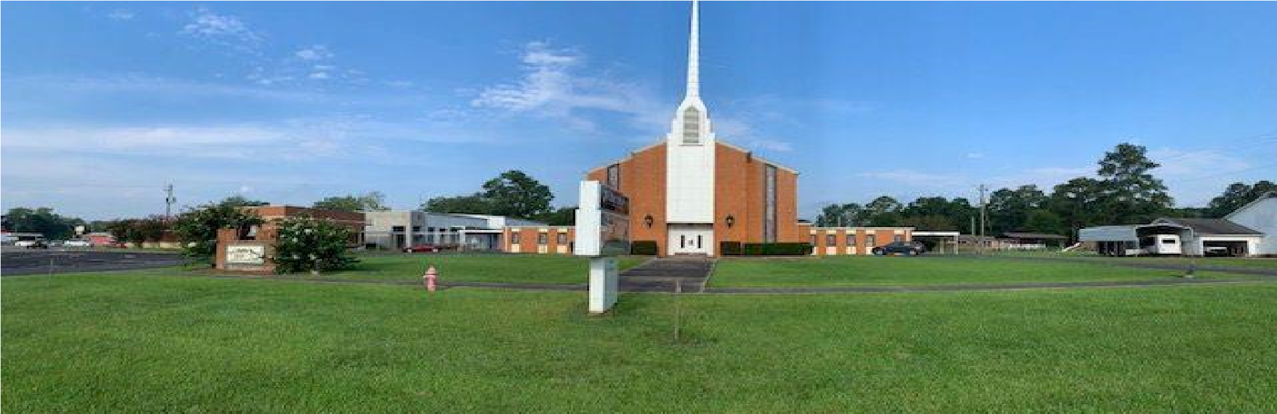

Our Mission
First Baptist Church of Taylorsville Christian School exists to honor our Lord by providing an educational environment that is rooted in the Bible and the traditions of our faith. Our goal is to educate children using a curriculum that reflects the faith and values of our Christian faith. "Teach a youth about the way he should go; even when he is old, he will not depart from it." (Proverbs 22:6, HCSB)
Our Statement of Faith
- We are affiliated with the Southern Baptist Convention and adhere to the “Baptist Faith and Message (2000)”. If you would like a copy of the “Baptist Faith and Message (2000)”, please see our office staff or for your convenience you may follow this link: Baptist Faith & Message 2000 - The Baptist Faith and Message (sbc.net).
- We believe the Bible is God-inspired and without error.
- We believe that every person is created in the image of God and should be treated with dignity, regardless of race, ethnicity, religion, or gender.
- We believe God's design for a family consists of one woman married to one man for a lifetime.
- We believe that everyone has sinned against God.
- We believe the "good news" is that Jesus died for our sins and that he rose from the dead.
- We believe that salvation is only possible through faith in Jesus Christ.
- We believe that real faith is more than words we might say. Our actions validate our claim to faith.
- We believe that God has called us to join him in world missions.
- We believe that we must begin engaging our world at our front doorsteps.
School Philosophy:
After acquainting yourself with the First Baptist Church of Taylorsville Christian School
Philosophy and Statement of Belief, describe your expectations regarding your child's education.

We appreciate your interest in applying for your child to attend First Baptist Church of Taylorsville Christian School. We view ourselves as partners with you in providing a robust Kingdom Education within a Christian community. Please complete this questionnaire and return it to us with the application. Attach additional sheets if necessary.

- Please describe how you integrate your faith into your family's daily life.

Family's Church Name:

Name Number of Years Attending

Please Check the appropriate boxes: [] Member [] Attends church regularly [] Belongs to youth group

- What are your reasons for seeking admission to First Baptist Church of Taylorsville Christian School? Also, please include your basis for transfer from your current school.

This application must be completed by or on behalf of all students seeking admission to First Baptist Church of Taylorsville Christian School. As the parent(s) or Guardian of the student applicant named hereinbefore, I/we state that we have read and agree with the Mission Statement, Statement of Belief, and School Philosophy of First Baptist Church of
Taylorsville Christian School. I agree that upon acceptance of the herein-named student, I/we will pledge to work with staff, administration, and faculty within these statements to improve our student and to assist and cooperate with the school in the Christian education of my/our child. I understand that the enclosed registration/book fee is non-refundable.
I further understand and acknowledge that continued enrollment of my/our child, if admitted to the school, shall be subject to the payment of all tuition and fees set forth on the schedule of tuition and fees as periodically amended by First Baptist Church of Taylorsville Christian School and my/our child's compliance with the code of conduct and policies stated in the student handbook established by First Baptist Church of Taylorsville Christian School.

X

Father or Guardian D a t e

X

Mother or Guardian D a t e

X

Student D a t e

Application for K5-9th Grade School Year Applied: 2024-2025

Date Applied:
Student Information

Student 1: Last ____________________ First ________________________MI______
24-25 Grade: _______ Circle: Male or Female DOB:________
IEP: Circle, YES or NO
Student 2: Last ____________________ First ________________________MI______
24-25 Grade: _______ Circle: Male or Female DOB:________
IEP: Circle, YES or NO
Student 1: Last ____________________ First ________________________MI______
24-25 Grade: _______ Circle: Male or Female DOB:________
IEP: Circle, YES or NO
Siblings attending FBC of Taylorsville Preschool or FBC Christian School: YES or NO

Name(s) of siblings: _____________________________________________________________________________

_______________________________________________________________________

Address: ___________________________City___________________State_____Zip_________

Home Phone: ______________________________Cell Phone: __________________________

FATHER: Full Name of Father (including title: Mr., Dr., Rev., etc.)

TITLE FIRST MIDDLE LAST PREFERRED
_________________________________________________________________________________________
Home Address City State Zip

Phone: Home Business

Cell

Employer Occupation

Email @

Mother: Full Name of Mother (including title: Mr., Dr., Rev., etc.)

TITLE FIRST MIDDLE LAST PREFERRED
_________________________________________________________________________________________
Home Address City State Zip

Phone: Home Business

Cell

Employer Occupation

Email @

Stepparents/Guardian(s): Stepfather Stepmother or Guardian ____ (include title: Mr., Mrs., Dr., Rev., etc.)

TITLE FIRST MIDDLE LAST PREFERRED
_________________________________________________________________________________________
Home Address City State Zip

Phone #: Home Business

Cell

Employer Occupation

Email @

Family Information

Student lives with ( ) Father ( ) Mother ( ) Stepmother ( ) Stepfather ( ) Legal Guardian
Student's parents are ( )Married ( ) Separated ( )Divorced

Please mark all that apply: ( ) Mother deceased ( ) Father deceased
Any legal custody situations of which FBC of Taylorsville Christian School should be aware: ( ) Yes ( ) No

If yes, please explain:
If divorced, please indicate the type of custody ordered by the court: ( ) Joint ( ) Sole

Which spouse holds legal responsibility for school decisions?
(Copies of all court documents regarding custody and educational decisions MUST be submitted along with the application.)
To whom should correspondence be sent? ( ) Both parents ( )Father ( )Mother

Medical History:
Does any student listed on this application suffer from chronic or acute illnesses such as diabetes, epilepsy, asthma, or allergies, etc.?

If so, please explain:

Specific instructions for treating the above:
_____________________________________________________________________________________

__________________________________________________________________________________________
May we have permission to give OTC medicine to the student(s) listed on this application?
(Tylenol, Pepto Bismol, Etc.) Yes or No

Emergency Medical Service Permission:

Should an accident or illness occur during the school day or on a school-sponsored activity which in the opinion of FBC of Taylorsville Christian School personnel requires immediate treatment, and the school is unable to locate either parent or Guardian, I authorize and empower the property of FBC of Taylorsville Christian School authority to act in our stead and obtain the required medical services for the above-named child.

X

Father or Mother or Guardian D a t e

Emergency Contacts

List two additional contacts to be used in the event parents cannot be reached:

- Name __________________________________Relationship ____________________________

Phone: _______________________Home_______________________Cell_________________________

- Name __________________________________Relationship ____________________________

Phone: _______________________Home_______________________Cell_________________________

Pick-Up Information:

- Name __________________________________Relationship ____________________________

Phone: _______________________Home_______________________Cell_________________________

- Name __________________________________Relationship ____________________________

Phone: _______________________Home_______________________Cell_________________________

